Experiment Report

311552024 詹偉翔

1. Introduction

In this lab, we will implement the image classification that is ResNet18 and ResNet50. Moreover, we will preprocess data by ourselves and using pre-Trained model. To see which models will be the best model with highest accuracy.

1. Experiment Setup
2. The detail of your model

I set the parameters below:

* learning rate = 0.005
* batch size = 12
* epochs = 10

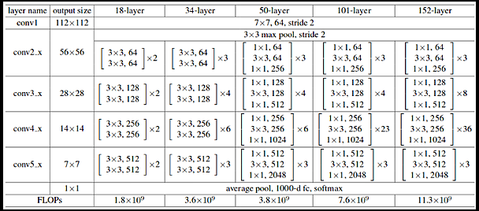

This is architecture of ResNet18 & ResNet50.

* 1. ResNet18

There are 18 layers in this model and it use residual learning, so it called ResNet18. I build this network with the ResNet18 architecture. In my code, there is _make_layer is used to build the blocks that used in conv2 – conv5 which is in previous picture. I get the pretraining weight from pytorch, get their layers, and used in my network.

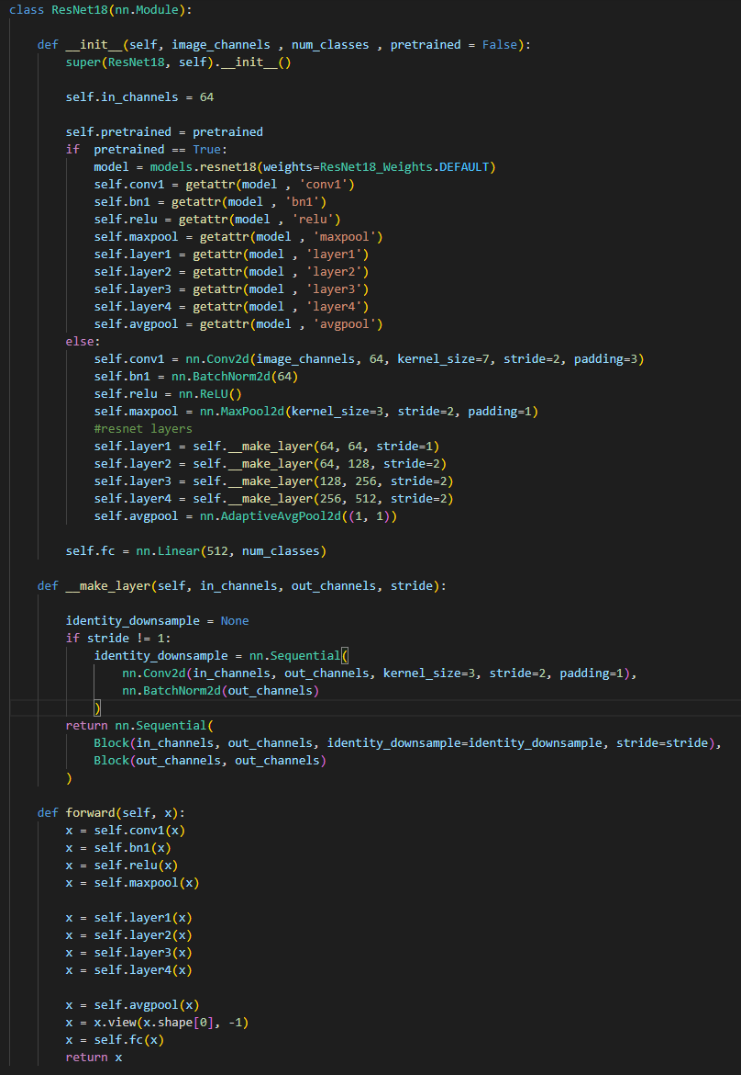

Here is my ResNet18.

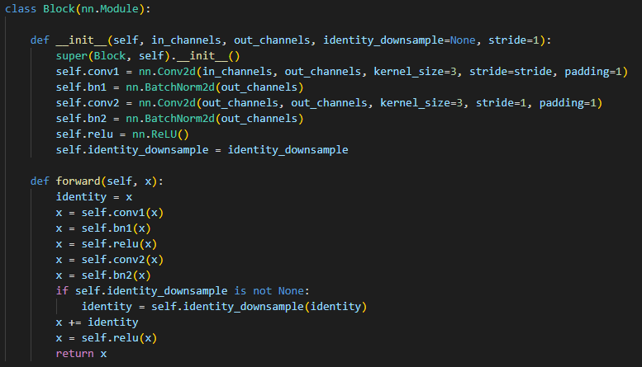

Here is my block.

* 1. ResNet50

This is 50 layers in this models and it use residual learning, so it called ResNet50. I build this network with the ResNet18 architecture. In my code, there is the same function I do in ResNet18, but there are some different in the block function and corresponding number of blocks.

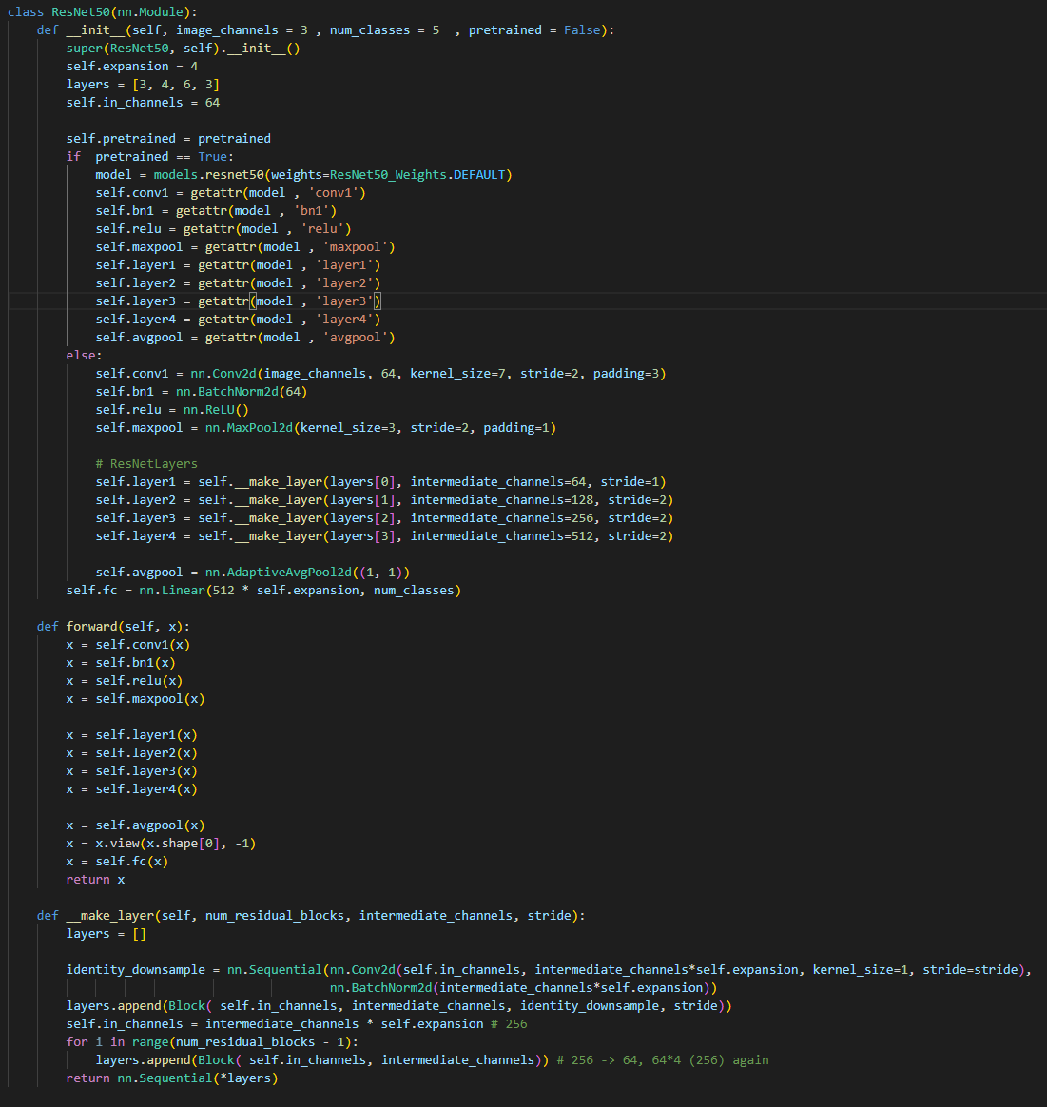

Here is my ResNet50.

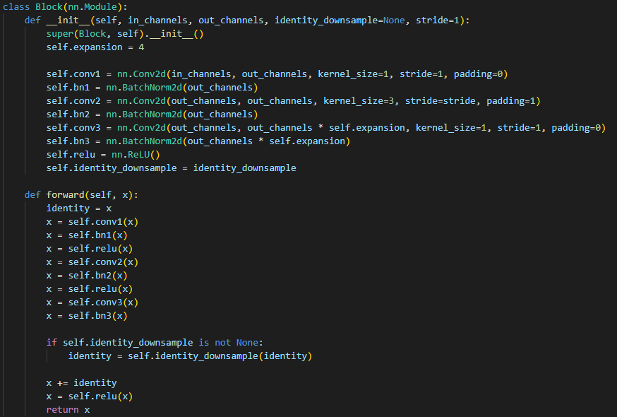

Here is my block.

1. The details of your Dataloader
2. we get the image name and label from csv file.
3. Implement the __getitem__ function. We do the preprocessing and resize the image to 512x512 in here.
4. Return our image and its label.
5. Describing your evaluation through the confusion matrix

I store the label and prediction in each list, and then use ConfusionMatrixDisplay.from_prediction() to get the confusion matrix with labels is 0~4 and normalization is true.

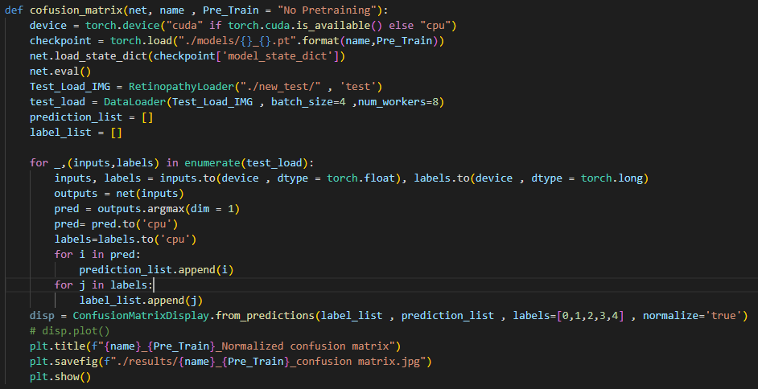

Here is my confusion matrix function.

1. Data Preprocessing
   1. How you preprocessed your data?
      1. I find the boundary of images.
      2. I count each pixel in each line. If all pixel in line is lower than 25, I think it is black and cut it down.
      3. I resize the image to 512x512
   2. What makes your method special?

I think the cutting black side is the special way in my method, because the model can only focus on the eye.

1. Experiment Results
   1. The highest testing models

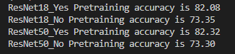

* ResNet18

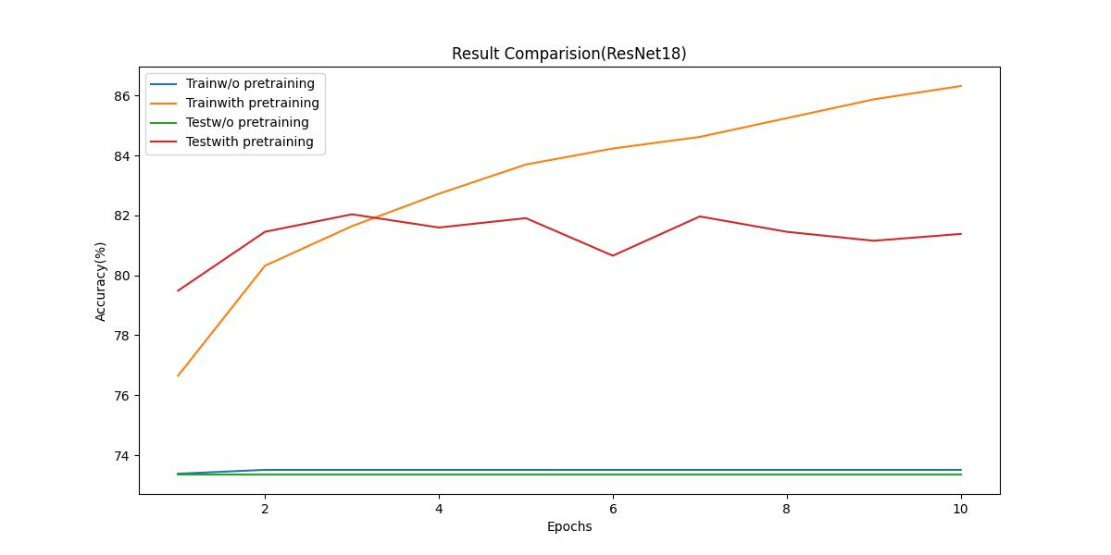

* ResNet50

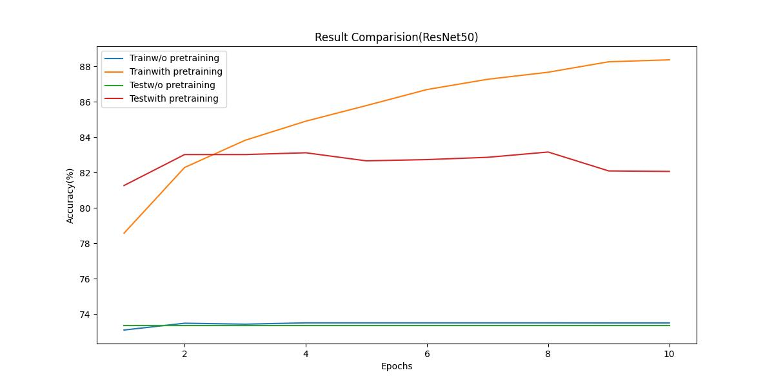

The models without pre-trained will be not able to predict well and can’t be trained better than previous epochs. But there is better performance in pretraining models.

* 1. Comparison figures
     1. ResNet18
        + Without Pretraining

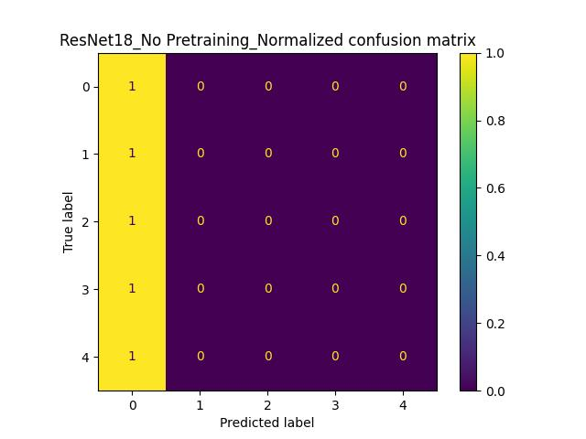

* With Pretraining

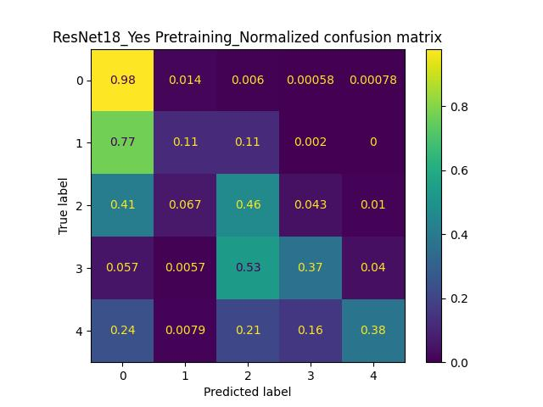

* + 1. ResNet50
       - Without Pretraining

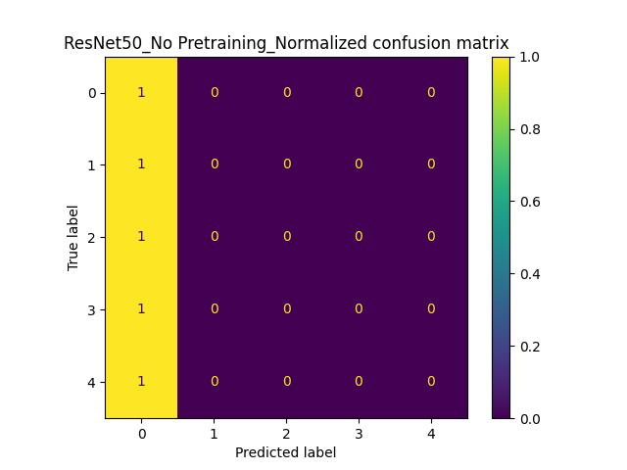

* + - * With Pretraining

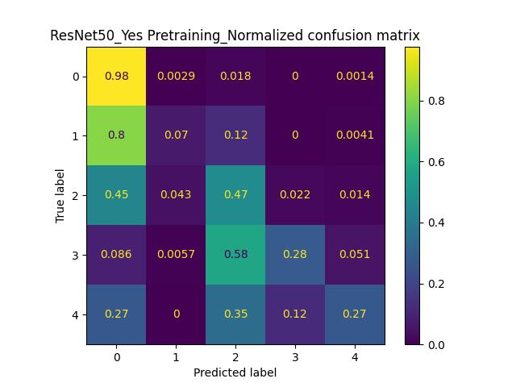

1. Discussion

There is a good problem that pretraining model can be trained better and better. But non-pretraining model can’t. I think the main reason is imbalance dataset. It can be easy to be found out by confusion matrix. The non-pretraining models are all guessing the answer is 0.